Design Technology
Mechanisms electrical Year 4
National curriculum |  |  |  |  |  |  | Vocabulary
KS2  Design  To use research and develop design criteria to inform the design of innovative, functional, appealing products that are fit for purpose, aimed at particular individuals or groups.  To generate, develop, model and communicate their ideas through discussion, annotated sketches, cross-sectional and exploded diagrams, prototypes, pattern pieces and computer-aided design .  Make  To select from and use a wider range of tools and equipment to perform practical tasks [for example, cutting, shaping, joining and finishing], accurately.  To select from and use a wider range of materials and components, including construction materials, textiles and ingredients, according to their functional properties and aesthetic qualities.  Evaluate  To investigate and analyse a range of existing products.  To evaluate their ideas and products against their own design criteria and consider the views of others to improve their work.  To understand how key events and individuals in design and technology have helped shape the world.  Technology  To understand and use electrical systems in their products (for example, series circuits, incorporating switches, bulbs, buzzers and motors). |  |  |  |  |  |  | assemble  battery  bulb  buoyancy  circuits  criteria  design  electrical  float  forces  join  method | modification  motor  power  propeller  risks  safely  sink  stages  switch  water  wires
Investigate  Technical knowledge |  | Design |  | Make |  | Evaluate
Year 3 / 4 – DT Skills
-Develop their own design criteria and use these to inform their ideas  -Evaluate products and identify criteria that can be used for their own designs.  -How simple electrical circuits and components can be used to create functional products |  | -Generate realistic ideas, focusing on the needs of the user  -Make labelled drawings from different views showing specific features  -Make design decisions that take account of the availability of resources  -Suggesting alternative methods of making, if the first attempts fail |  | -Measure, mark out, cut and shape materials and components with some accuracy  -Assemble, join and combine materials and components with some accuracy |  | -Refer to their design criteria as they design and make  -Use their design criteria to evaluate their completed products
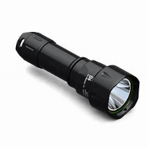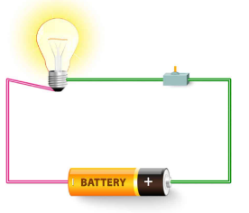 |  | 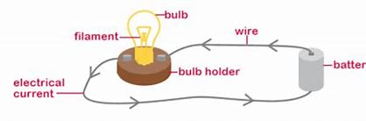 |  | 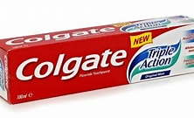  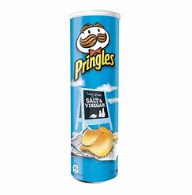 |  | 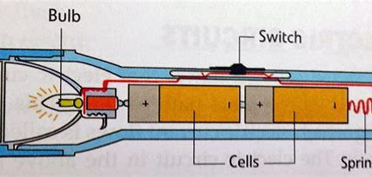
Learning Objectives | Lesson outline
Lesson 1: Investigate/ Practical skills  LO: To research and gather ideas to inform their own designs.  DT Skills: -Evaluate products and identify criteria that can be used for their own designs.  How simple electrical circuits and components can be used to create functional products | Introduction – Explain the children will be designing and making a torch.  http://www.youtube.com/watch?v=qRZ5lHMUB68  Before we make the torch, we need to explain the first 2 lessons will be investigating how to design and make a working torch focusing on electrical components and other design features. Recap science and simple circuits  Can the children name the components of a circuit?  Children to look at real torches. What will they need to consider when designing?  Examples of different kinds of torches (flashlight, hand-held, pocket size and larger industrial torches etc and different uses. - photographs of different types and real torches to look at.  Children to explore the different torches and disassemble them to see what the components are and how they are assembled to make a working product.  What do they have in common?  How are they adapted for different uses? Look at the shape of the torches. Is there a reason for this? Does the size reflect on the use of the torch?  Look at the features found on a torch.  For example, Bulb, switch, battery, casing for torch to be held. Shape and size of torch depending on the purpose  List as a tool kit/check list for display with correct terminology.  LA- Children to be given torch template (if needed) to design and include own design criteria (support if needed with labelling diagram)  EXS- Independent- Draw their own torch and chose design criteria thinking about purpose for use. Label with correct terminology or circuit components  GD- Children to design their own torches considering examples shown. Explain why they have chosen this design with more detailed explanations?
Lesson 2: Design  LO: To produce a design for product (torch) thinking about users’ needs.  DT Skills: Develop their own design criteria and use these to inform their ideas.  -Generate realistic ideas, focusing on the needs of the user  -Make labelled drawings from different views showing specific features  -Make design decisions that take account of the availability of resources | Design a torch.  Children choose who they are making a torch for and create own design criteria of what it must include or consider.  What does the electrical circuit look like? Can the children remember what it includes and their names and functions?  Size and purpose,  Audience and needs of the user,  Aesthetic detailing of the product,  Features of their torch and why they have chosen these?  Availability of the products.  Think about the casing for the torch and how this electrical component will be fitted, could have a range of materials I.e., toothpaste boxes, pringle tubes, etc. (material size will need to be based around their design size)  Children will need to create a design sheet focusing on drawing and labelling their design showing specific features. How they will perform the practical task of making the torches (cutting, shaping, joining and finishing)  LA- Design the torch they are going to make with resources available. Label diagram using key vocabulary.  EXS- Design the torch they are going to make with resources available. Can they use a variety of resources? Label diagram using key vocabulary. Explain why they chose these resources giving details of functionality, aesthetic, size etc.  GDS- Design the torch they are going to make with resources available. Can they use a variety of resources? Label diagram using key vocabulary. Explain why they chose these resources giving details of functionality, aesthetic, size etc.  Can they draw a variety of diagrams showing different views?
Lesson 3: Investigate/ Practical skills  LO: To understand how to make electrical circuits suitable for product (torch).  DT Skills: How simple electrical circuits and components can be used to create functional products | Pupil led investigation- Practical activity lesson  Investigating making circuits to light a bulb and introducing different switches.  What will they need the switch for? Can they think of any other electrical product that requires a switch?  The children will need to use these electrical components within their designs to make a working torch.  Refer to electricity covered during science.  How did we make the light bulb work? What was needed in the circuit? What will we need to make the circuit for our design? - bulb, switch, wires and battery.  Children to be given a range of equipment to begin making their product. Some of the resources given may be irrelevant and not needed.  Children to work in pairs to create a circuit including a switch.  Discuss how we can adapt this circuit, so it is suitable for our torch and size. Can they do this? What problems will or could occur? How will they solve these?  Children to investigate, feedback to class and share idea of different type of circuits made.  Mixed ability pairs- All children to be given same resources (support from GD pupils or adults if needed but children must try to solve the problem before intervening)
Lesson 4: Make  LO: To understand and use electrical components when making product (torch).  To assemble, join and combine materials and components with accuracy.  DT Skills: How simple electrical circuits and components can be used to create functional products  -Measure, mark out, cut and shape materials and components with some accuracy  -Assemble, join and combine materials and components with some accuracy  -Suggesting alternative methods of making, if the first attempts fail  - Refer to their design criteria as they design and make. | Children will make their torch today focusing on their design criteria and the electrical component of the design.  Recap torches and electrical circuits.  What do they need to be able to work?  Children to collect resources first to make their torch (recyclable materials provided) Children will need to use all the skills demonstrate to be able to cut, join, combine and mark out materials appropriately.  After their torch casing has been made (following design criteria) children can them collect resources to make the electrical circuit. Have they remembered what worked in lesson 2? (irrelevant resources)  Can they get the light and switch working?  Children to then assemble the torch materials including the electrical circuit inside.  Does it look and work like their initial design? If not, why?  LA- Support with joining, cutting and measuring  EXS- Independent activity- some support if needed with making  GD- Independent- Can they children use more than one bulb to make the torch brighter?  .
Lesson 5: Make  LO: To make quality products finish to a high standard.  (As lesson 4)  DT Skills: How simple electrical circuits and components can be used to create functional products  -Measure, mark out, cut and shape materials and components with some accuracy  -Assemble, join and combine materials and components with some accuracy  - Suggesting alternative methods of making, if the first attempts fail.  - Refer to their design criteria as they design and make. | Make - focusing on finish of the torch.  Look at torches so far.  What is the structure like?  Does it work yet?  If not, what do you need to change to make it work?  Is there anything you would like to change about the design/circuit? Why?  Children to be given the chance to make changes to design before they continue making.  LA – Support with joining cutting and measuring  EXS – Independent activity (support if needed)  GD – Independent – Can they include more than 1 bulb to make the torch brighter?
Lesson 6: Evaluate  LO: To evaluate a finished product based on appearance, purpose, quality and user’s needs.  DT Skills: Use their design criteria to evaluate their completed products | Children to create an advertisement for their torch. Who was the torch designed for? What would make it appeal to their target audience?  How does the torch work? Is it simple to use? Would this make people want to buy it more? Create a poster that would persuade people to buy the torch.  Children then need to evaluate their final product.  What do they like about their design?  What don’t they like about their design?  What would they change if they were to do it again?  LA – Simple sentences My favourite part of my torch is ______ If I were to do it again I would _________  EXS – Simple sentences explaining why. If I were to make the torch again, I would change ____________. I would change this because ______________.  GD – Evaluate final product (all the above) including, is there design suitable for the target audience? Yes/no and explaining why?
Working towards |  |  | End of unit assessment  Working at Age related expectations |  | Working at a greater depth

